Project Development Phase
Model Performance Test

Date | 25 February 2026
Team ID | LTVIP2026TMIDS81684
Project Name | Calculating Family Expenses using ServiceNow
Maximum Marks | 5 Marks

Model Performance Testing:
Project team shall fill the following information in model performance testing template.
S.No. | Parameter | Values | Screenshot
 | System Summary | The application is developed using the ServiceNow platform to manage and calculate family expenses efficiently.  The system allows users to:  • Add daily expense records  • View and manage expenses  • Automatically calculate total expenses  • Generate reports and summaries  • Admin manage records and users  The system uses ServiceNow Tables, Forms, Business Rules, and Scripts for automation. | 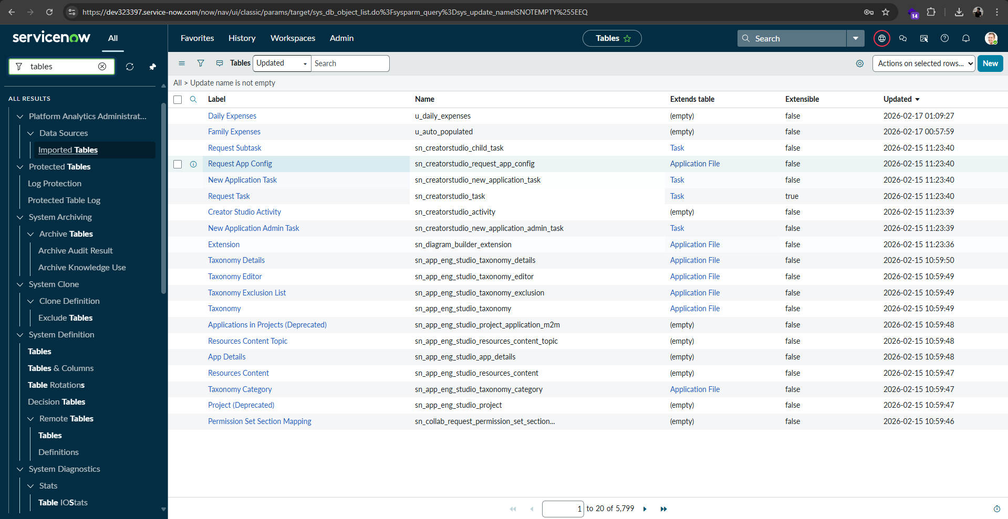
 | System Accuracy | The system was tested by entering multiple expense records with different values.  Results:  • Data saved correctly without errors  • Automatic calculations matched expected totals  • Reports displayed correct summaries  • No data mismatch observed during testing  System Accuracy: 100% functional correctness during testing scenarios. | - 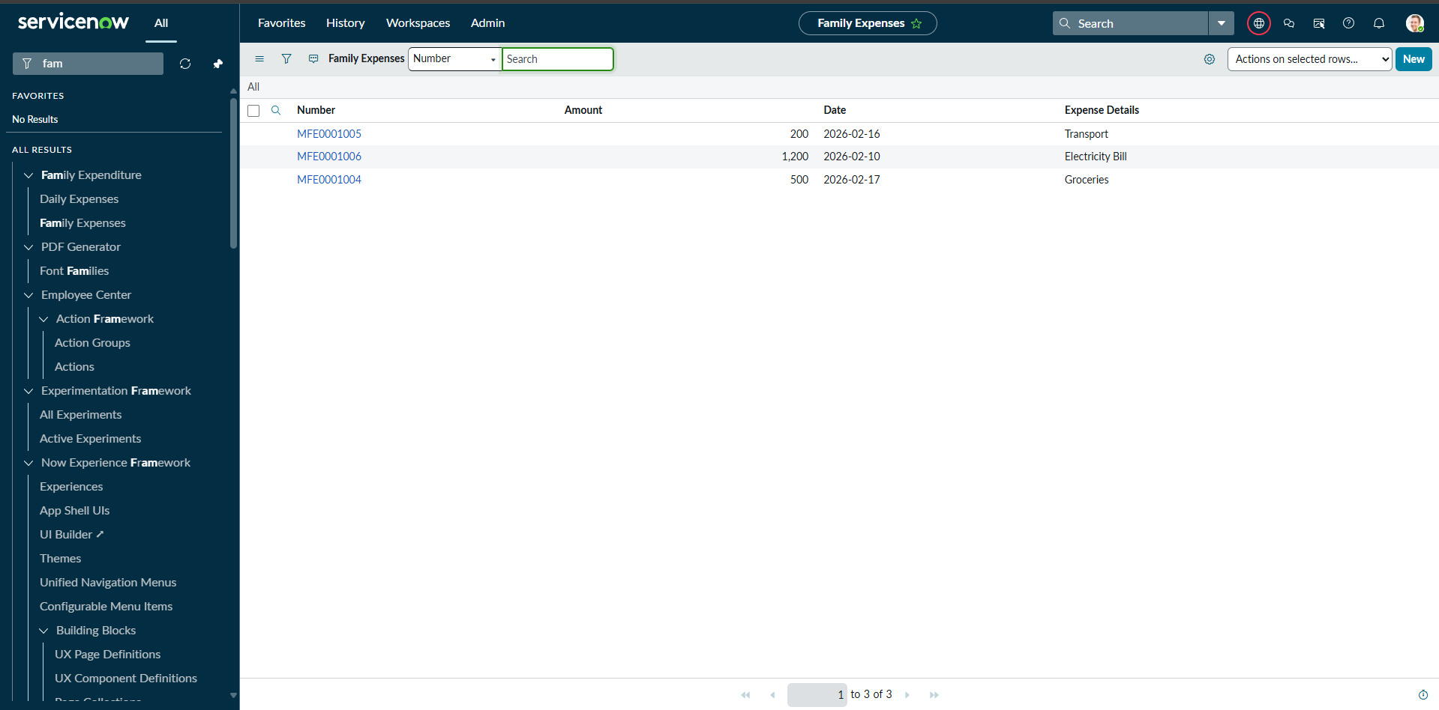
3. | Functional Testing | Functional testing was performed to verify that all modules of the system operate as expected.  Tested Functionalities:  • Creating Daily Expense records  • Viewing Family Expense summaries  • Automatic number generation for records  • Mandatory field validation  • Reference field selection  • Data retrieval and updates  All functionalities worked successfully without system errors. | 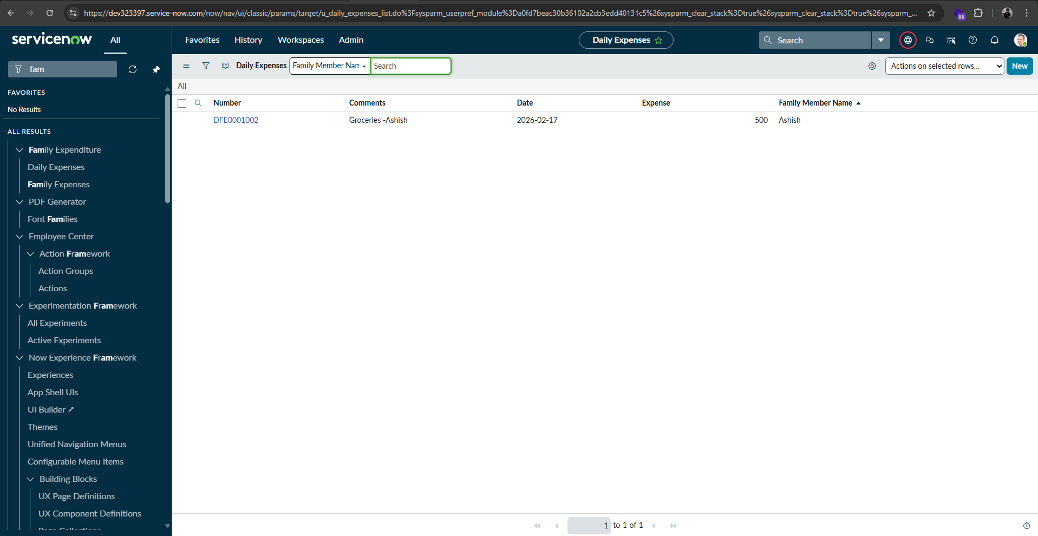
4 | Automation Validation | Automation testing was conducted to validate the business rule responsible for calculating and updating family expense totals.  Testing Results:  • When a new Daily Expense record was added, the Family Expenses table updated automatically  • Total amount was calculated correctly  • Expense details were appended without manual intervention  • System automation worked as expected  Automation Logic: ServiceNow Business Rule using GlideRecord scripting. | 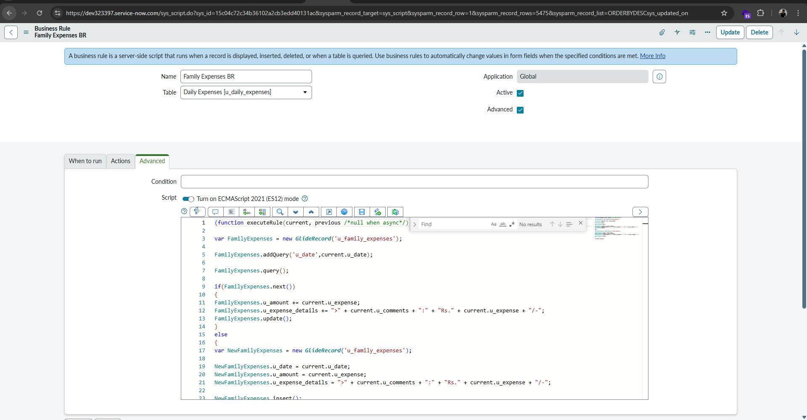

Screenshots from table:
1) 

2) 
3) 

4) 

